EXPERIMENT 6

DML COMMANDS (COLLEGE SCHEMA)

Aim:

· Insert 5 instances into the tables created in experiment 6.

· Display the tables.

· Add attribute course to student table then insert values.

· Use update to set course for students.

· Delete an attribute.

**QUERIES**

· Insert 5 instances into the tables created in experiment 6.

· Display the tables.

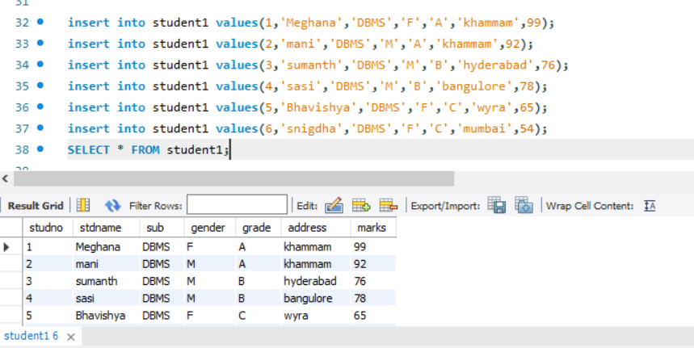

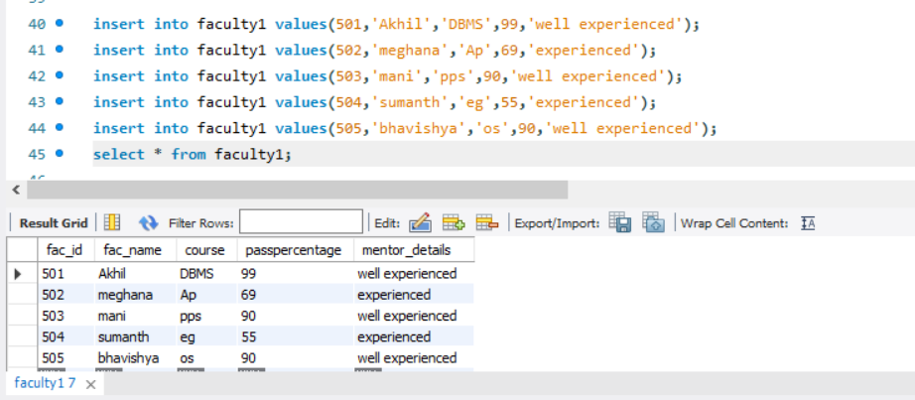

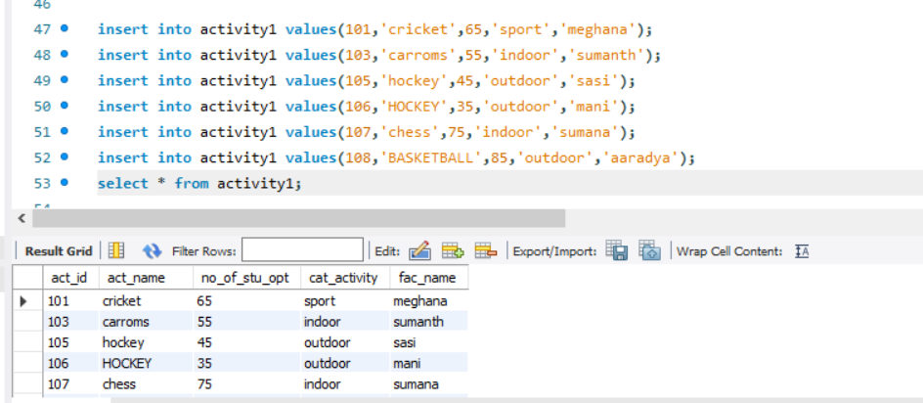

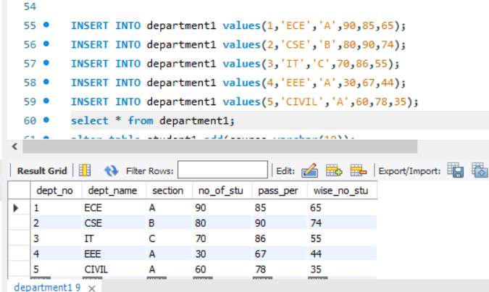

· Add attribute course to student table then insert values.

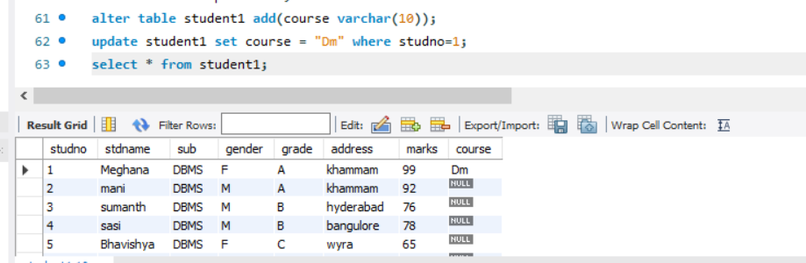

· Use update to set course for students.